Lab 4

Lab Activities:
Solve the below series circuit. To find unknown quantities as mentioned in worksheet. Choose the values of resistors of your own choice
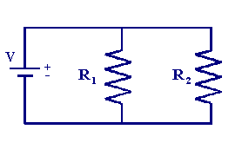
Figure 2

Table 1
Resistor | Band 1 |  | Band 2 |  | Band 3 |  | Resistance | Band 4
Resistor | Color | Value | Color | Value | Color | Value | $$Ω$$ | Color | Tolerance %
1 | Blue | 6 | Violet | 7 | Black | 0 | 67 | Green | ±0.5%
2 | Green | 5 | Orange | 3 | Brown | 1 | 530 | Blue | ±0.25%

Procedure: Determining Equivalent Resistance-Series Arrangement
- Connect the two resistors in a parallel arrangement.
- Supply 5V to the circuit
- Find the values of four resistors
- Find the voltage and current across R1 and R2

Voltage Through Multisim
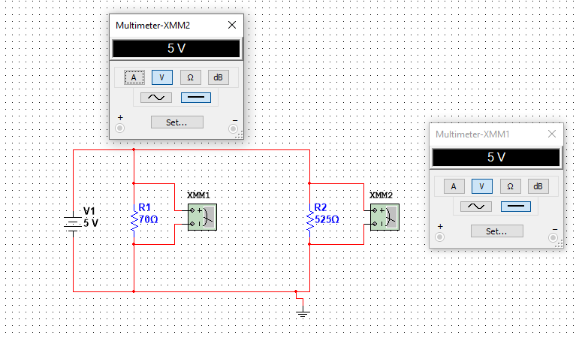

Current Through Multisim
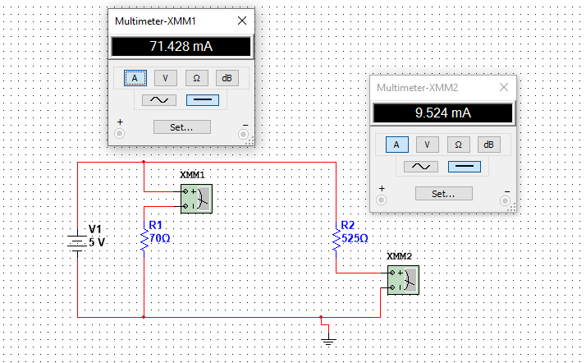

Current and Voltage Manually found
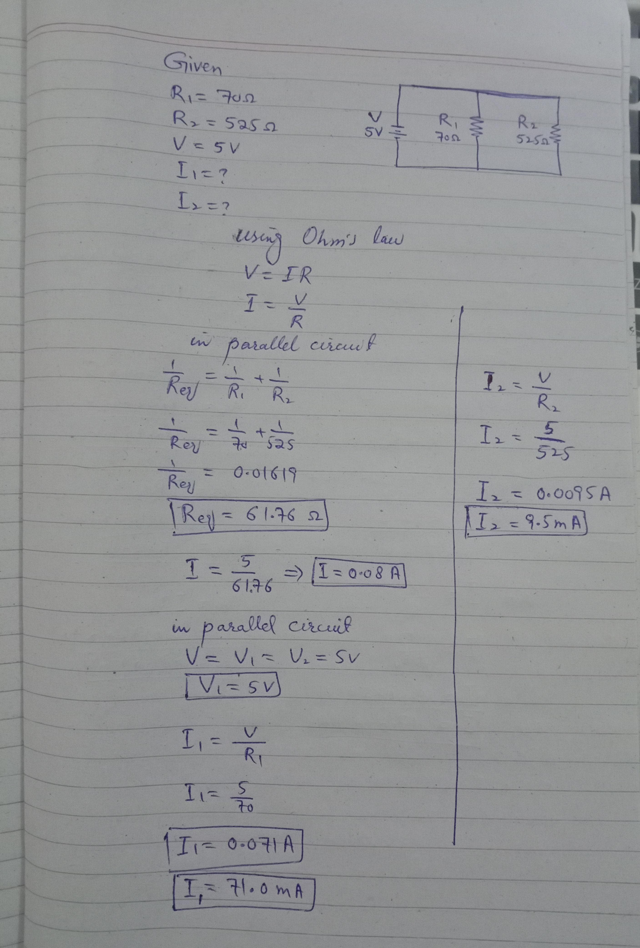
Worksheet
Table-2
Resistors | R1 | R2
R (Nominal) | 67 | 530
R (Actual) | 70 | 525

Table-3
Values | V | I1 | I2
Measured | 5V | 71.42mA | 9.524 mA
Calculated | 5V | 71.0 mA | 9.5 mA

Lab Exercise

1. Solve the following circuits and attach solve results on A4 page, MultiSim result and also Elvis Kit result.
Task-01
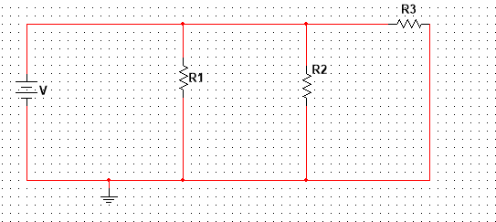

Resistor | Band 1 |  | Band 2 |  | Band 3 |  | Resistance | Band 4
Resistor | Color | Value | Color | Value | Color | Value | $$Ω$$ | Color | Tolerance %
1 | Brown | 1 | Black | 0 | Red | 2 | 1k Ohm | brown | ±1%
2 | Green | 5 | Orange | 3 | Brown | 1 | 530 Ohm | Orange | ±3%
3 | Blue | 6 | Black | 0 | Red | 2 | 6k Ohm | Gold | ±5%

Procedure: Determining Equivalent Resistance-Series Arrangement
- Connect the two resistors in a parallel arrangement.
- Supply 5V to the circuit
- Find the values of four resistors
- Find the voltage and current across R1, R2, and R3

Voltage Through Multisim
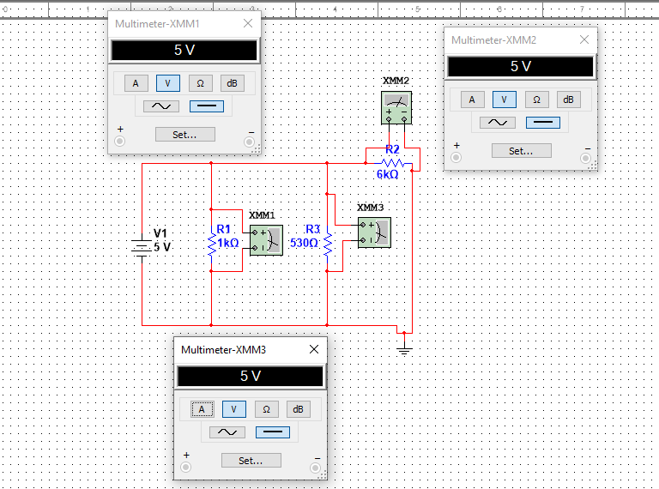

Current Through Multisim
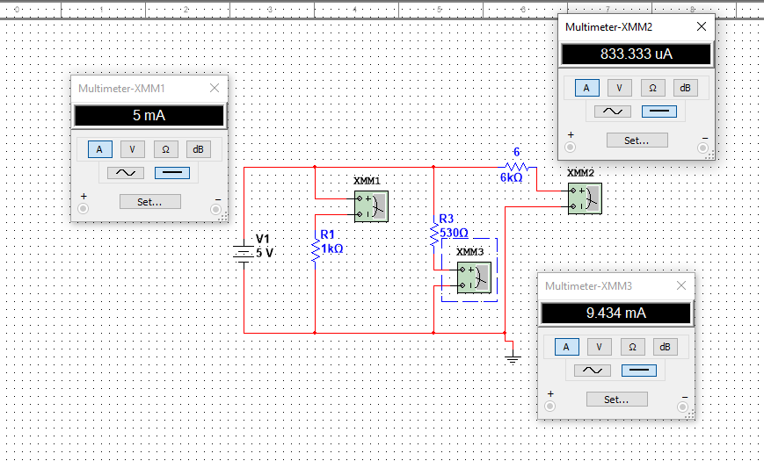

Current and Voltages Manually Calculated
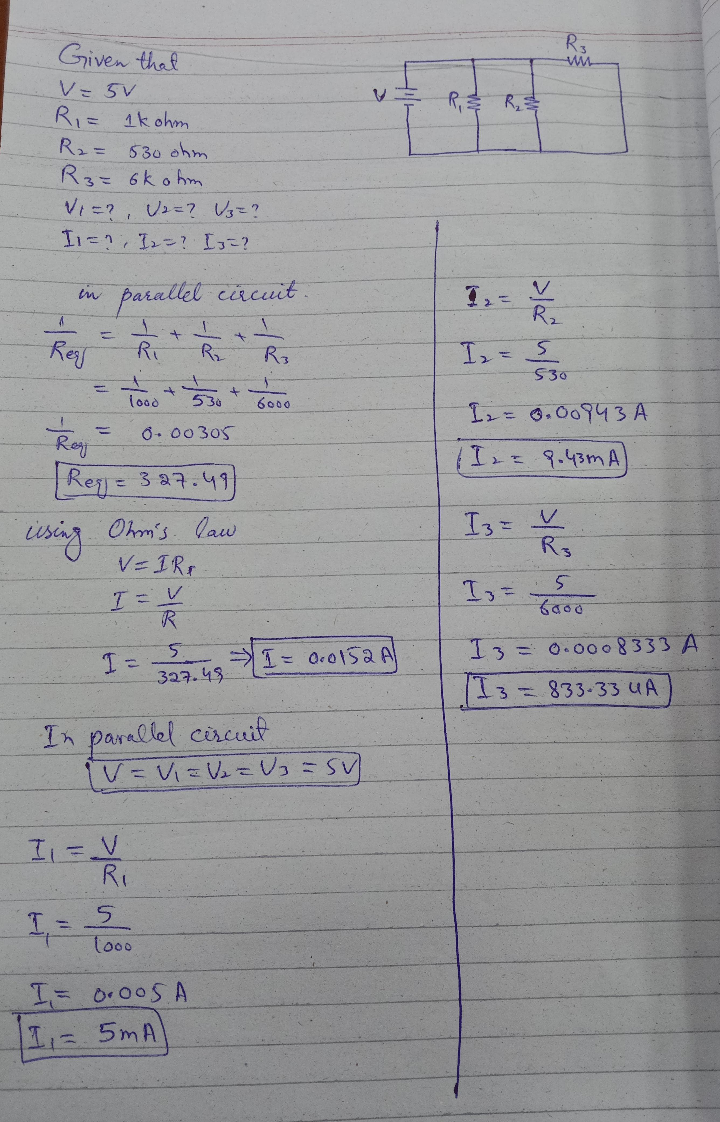

Worksheet
Table-2
Resistors | R1 | R2 | R3
R (Nominal) | 1k ohm | 530 Ohm | 6k Ohm
R (Actual) | 1k ohm | 530 Ohm | 6k Ohm

Table-3
Values | V | I1 | I2 | I3
Measured | 5V | 5mA | 9.434mA | 833.33uA
Calculated | 5V | 5mA | 9.433mA | 833.33uA

2. Solve the following circuits and attach solve results on A4 page, MultiSim result and also Elvis Kit result.
Task-02
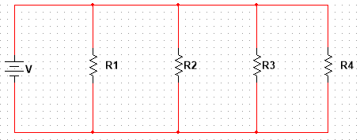

Table-1

Resistor | Band 1 |  | Band 2 |  | Band 3 |  | Resistance | Band 4
Resistor | Color | Value | Color | Value | Color | Value | $$Ω$$ | Color | Tolerance %
1 | Brown | 1 | Black | 0 | Brown | 1 | 100 Ohm | brown | ±1%
2 | Red | 2 | Black | 0 | Brown | 1 | 200 Ohm | Orange | ±3%
3 | Yellow | 4 | Black | 0 | Black | 0 | 40 Ohm | Gold | ±5%
4. | Green | 5 | Black | 0 | Black | 0 | 50 Ohm | Blue | ±0.25%

Current on Multisim
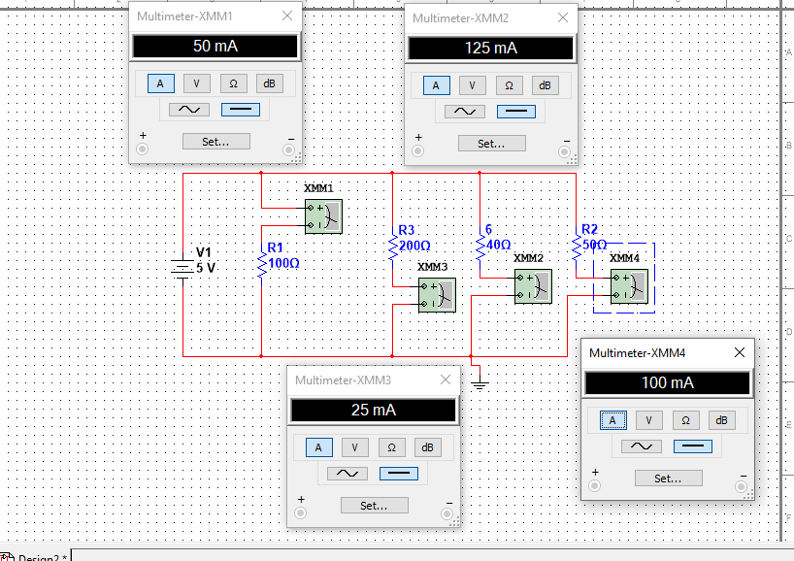

Voltage on Multisim
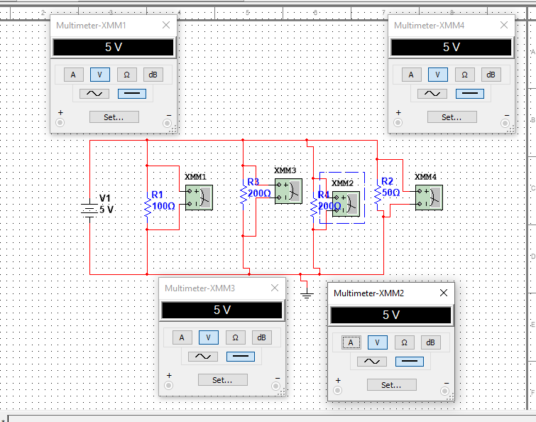
Current and Voltages Manually Calculated
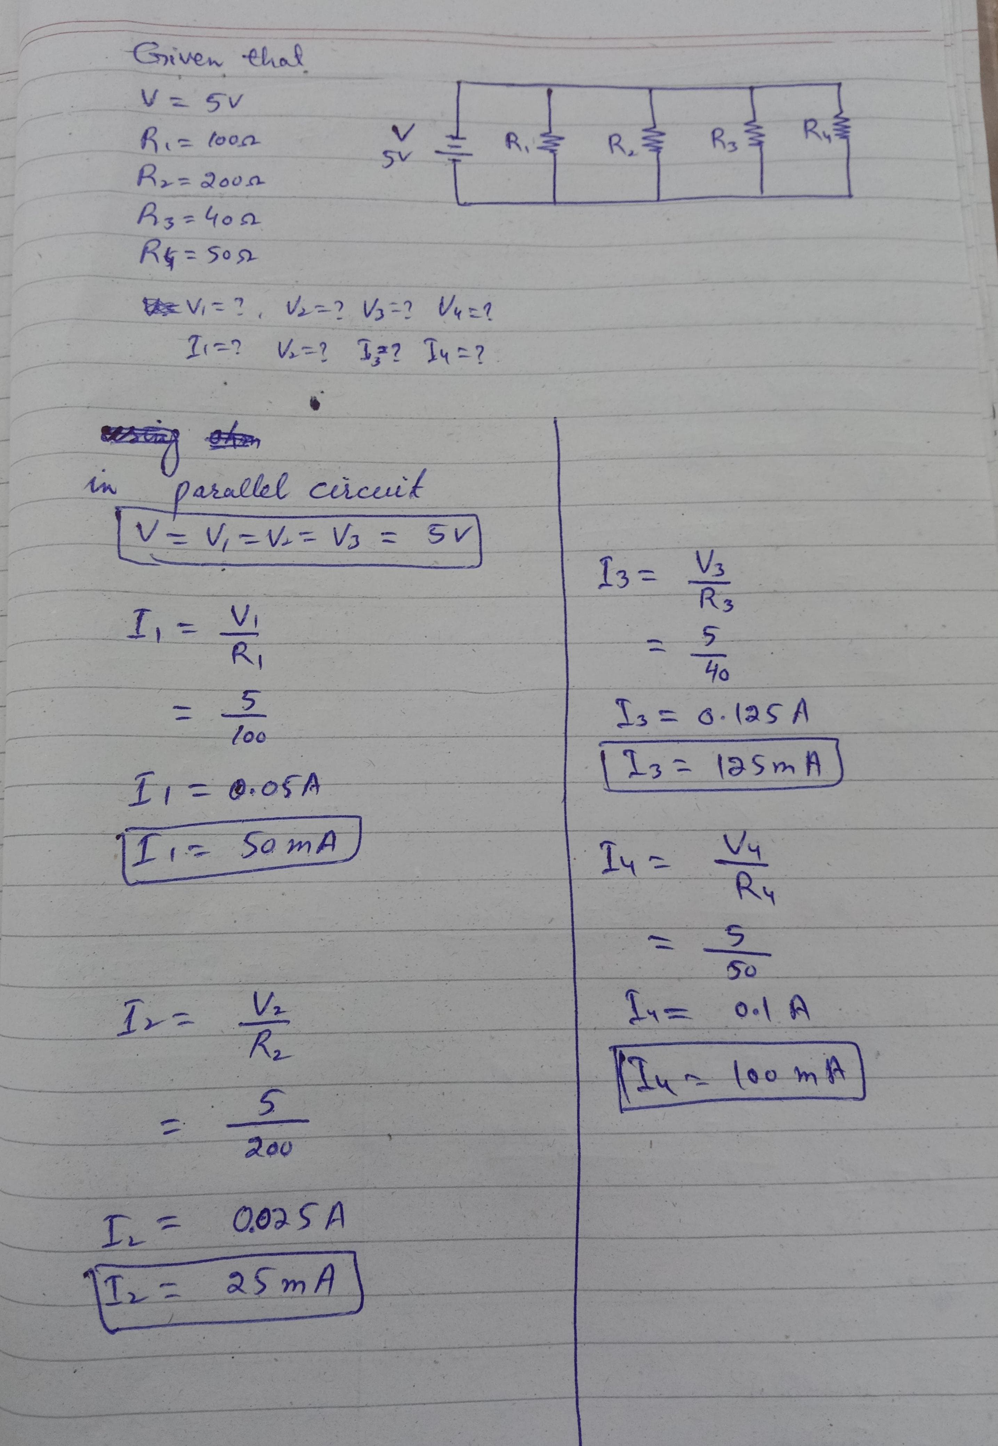

Worksheet
Table-2
Resistors | R1 | R2 | R3
R (Nominal) | 100 ohm | 200 Ohm | 40 Ohm
R (Actual) | 100 ohm | 198 Ohm | 41 Ohm

Table-3
Values | V | I1 | I2 | I3 | I4
Measured | 5V | 50mA | 25mA | 125mA | 100mA
Calculated | 5V | 50mA | 25mA | 125mA | 100mA

